Robot Model

The robot is modelled around keeping loyalty to a Master, in this model we refer to the master as “Owner”. When the robot is started it first checks how much sleep it has had and compares it to the amount of sleep it needs. Less than eight hours and the robot is angry. The robot then waits for an object to aproach. An object approaching too fast scares it. If the object is going slow enough the robot captures an image and checks it to see if there is a match to the owner.

If the owner is identified correctly the robot becomes happy and becomes able to understand spoken instructions. If the robot does not understand the command it will stay in this state. If the robot is told to walk it will ove towards it’s owner. If the robot is told to wait it will remain in this state of wating for a command but will additionally be monitioring the time it has waited for. If the wait time is over thirty minutes the robot enters a sad state. If the wait time goes over forty minutes in total the robot will become angry and require attetion from the owner to return it to a happy state.

## Simulator

Here is the screenshot from console about a running simulator of the robot in Rhapsody:

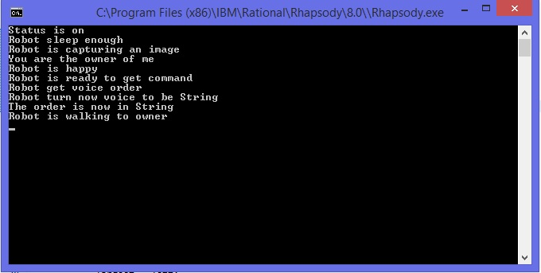

1. The robot simulator is setup, it starts with “the robot is on” state.
2. The robot checks that it has slept for 8 hours, then waits for input.
3. An object approaches at less than 2 m/s and the robot captures an image.
4. The object is identified as the owner.
5. Robot is happy.
6. Robot is waiting for a command.
7. Robot recieves a spoken command.
8. Robot interprets the command.
9. order is now a string
10. Robot walks to the owner.

## Contributions

## Saipirun Sanprom

Produced working Rhapsody model, ClassDiagram and StateChart Design

## Shan Jiang

ClassDiagram and StateChart Design

## Michael Warne

Documentation, error checking, StateChart diagram

## Lucas Van Egeraat

Logic for all diagram and for robot emotion, Java code

## Marcus Näslund

Giving advice

## Philip Malm

Giving advice